Analysis and Design

4.1- Overview
In previous chapter we discussed the problem statement and scope of this project. In this chapter we have discussed the analysis and design considerations we carried out for this project.

This chapter highlights the analysis done through data collection and various other techniques and designing steps for developing the software. Then we have described the use case model. And finally we have described the data flow diagrams.

4.2- Survey
This project is commercial based and targeted towards potential customers who need such type of intelligent automated assistant. Hence the requirements and features added in this system were chosen after observing needs of potential users of this system.

Since this project is based on Computer Telephony Integration (CTI) so we tried to collect information from various sources where CTI based applications are being developed. But unfortunately we were unable to get any technical help from local area. The main problem with us was that not many people have worked on development of CTI based application. Most of such type of applications used in marked, are imported products from foreign market. The main data source used was internet. We collected information about the different tools and strategies to develop CTI based application. We analyzed some of the products developed on CTI.

4.3- Data Collection
Since we were unable to collect required knowledge from local people so we had to rely on internet for collecting information about telephony programming interfaces. We gathered information about Telephone APIs (TAPI) to control telephone calls and how they could be used in developing a CTI based application.

Sir Ale Imran Rizvi, who is faculty member of our university, provided us with great help related to controlling the hardware circuitry in our project. He described us about the issues like how to handle problem of low voltage supply from PC for a high voltage circuitry, microcontroller chip programming issues etc.

The materials provided from faculty and websites visited for data collection, relevant to our project, are indicated in reference (see Reference Section).

4.4- External Interface Requirements
IA includes electronic circuits and some hardware to be functional. The table below (Table 4.1) shows the external face requirements and their usage.

Requirement | Quantity | Usage
Telephone line | 1 | To be connected in modem for controlling telephone operations.
5 volt DC power supply | 1 | To power up microcontroller & other circuitry.
12 volt supply | 1 | To power up switching relays
220 volt AC supply | 1 | To be provided to device controlling circuitry.
Voice modem (TAPI enabled) | 1 | To control telephony operations.

Table 4.1: External interface requirements

4.5- Software Requirements
Software requirements for system to be working are
- Windows 98/ 2000/ XP.
- amTapi Pro OCX library.
- TSP (telephone service provider) driver

.
4.6- Process Flow Diagram
As we discussed in Chapter 1 (see section 1.4) that our system is divided intro four modules that are:
- IA interaction with phone caller-client.
- IA interaction with visitor / door-client.
- IA interaction with microcontroller.
- IA interaction with system owner.
Below is the overall process flow diagram. We’ll look process flow diagram for each module
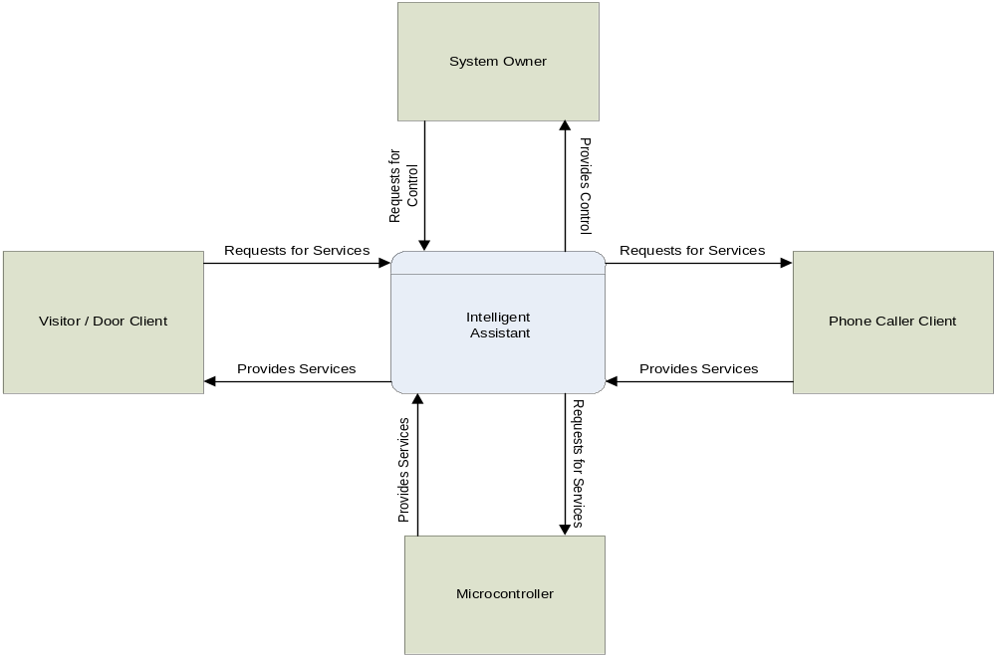
Figure 4.1: IA Interaction with Phone Caller-Client
4.6.1- Phone Caller-client Interaction with IA
Phone caller-client is the person who calls at to system owner. IA attends the call and provides options to caller to choose different services. A phone caller client can:
- Record his voice message for system owner.
- Listen his recorded voice message.
- Re record his voice message.
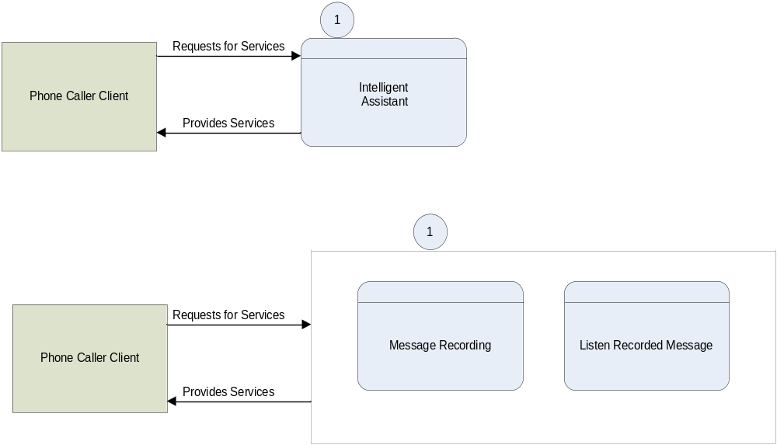
Figure 4.2: Process flow diagram-phone caller client interaction with IA

4.6.2- IA interaction with Visitor / Door-Client
Door client interaction process begins when he presses bell on gate. IA answers him with an audio message and provides him different options like:
- Record his voice message for system owner.
- Listen his recorded voice message.
- Re record his voice message.
- Requests to IA to call to system owner.
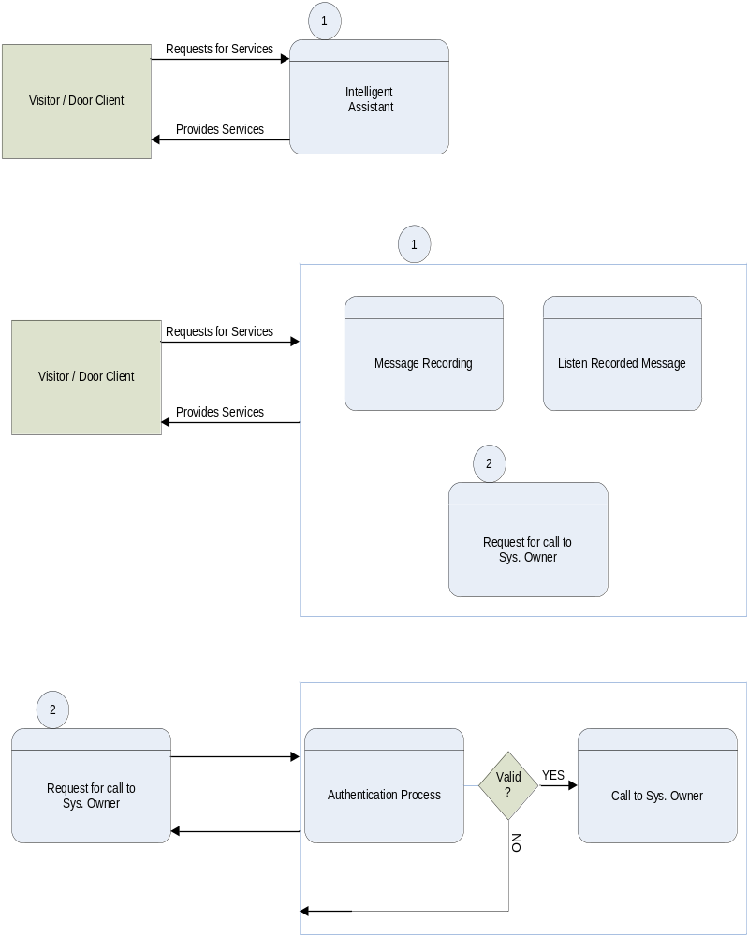

Figure 4.3: Process Flow Diagram- visitor / Door Client interaction with IA
4.6.3- IA Interaction with Microcontroller
IA communicates with Microcontroller through printer port. Microcontroller is responsible to control Device switching circuit and recognition of punched keys on electronic key pad, on IA’s command to microcontroller.

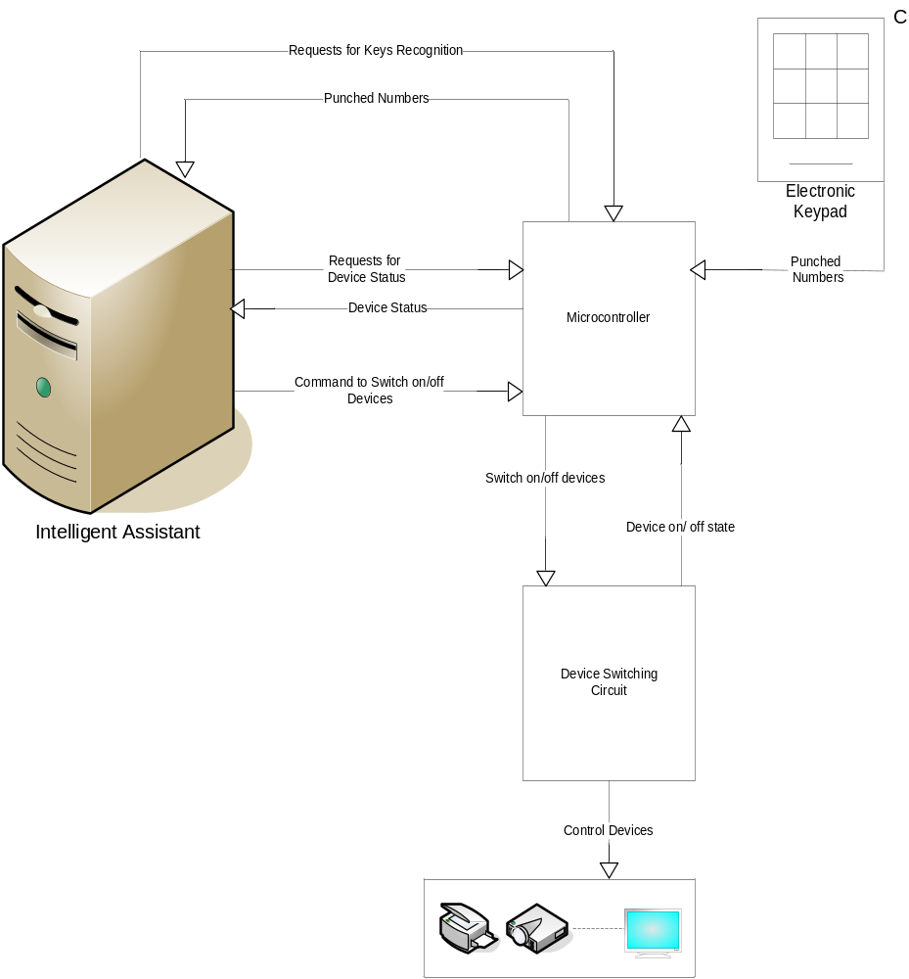

Figure 4.4: Process Flow Diagram-IA interaction with microcontroller.
    - IA interaction with System Owner
This is the main and the biggest module of this project. Owner of this system will connect to IA, via phone call, after verifying his/her password. System owner, then can have options like:
- Listen / delete all voice messages of clients.
- Change administrator login password.
- Change the phone# dialed by IA to call to system owner.
- Enable / disable calling service for door-client.
- Control Electrical device connected to the system.
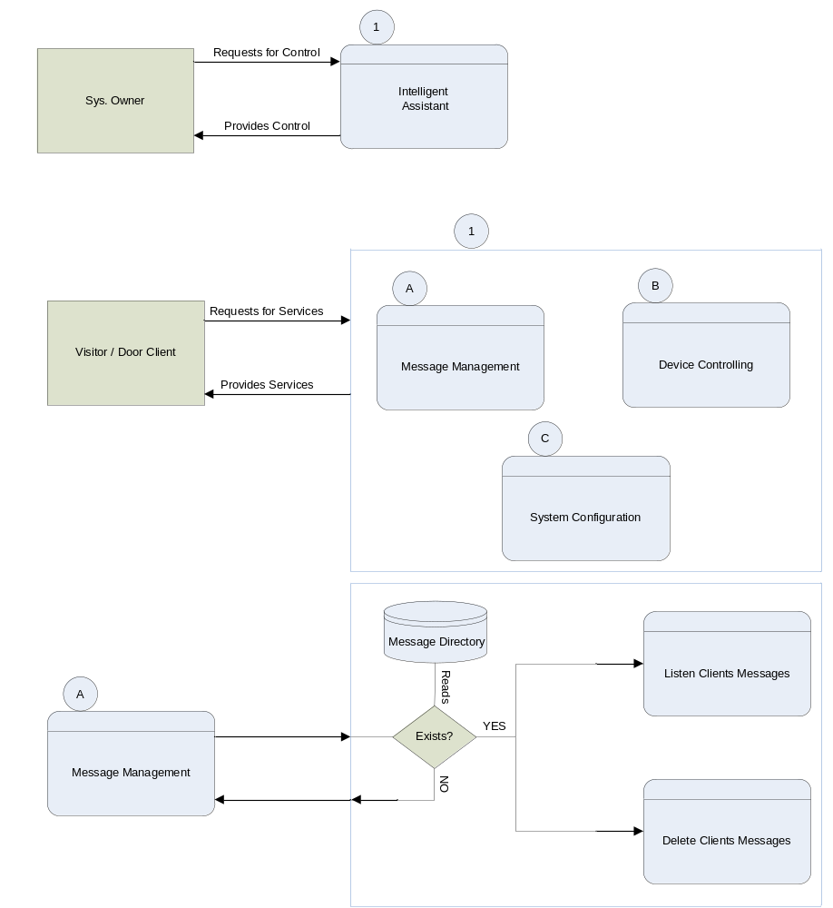
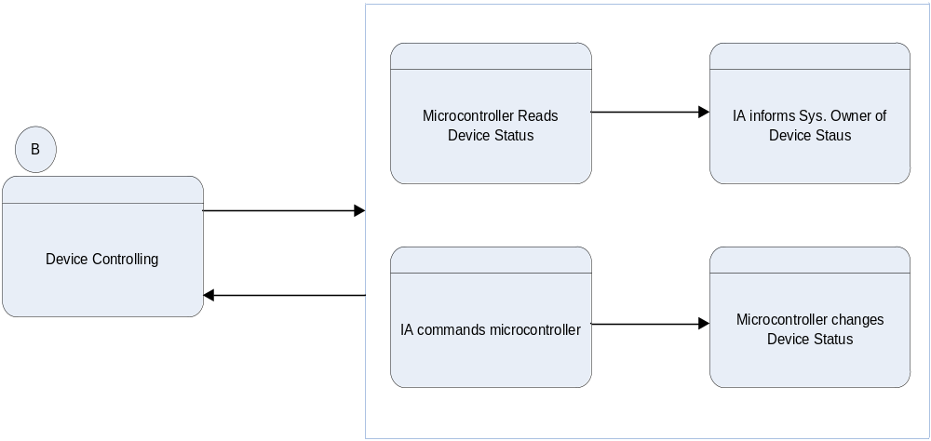

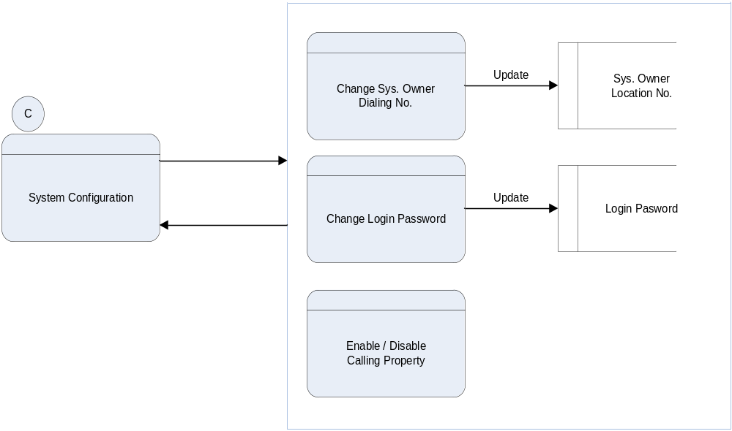
Figure 4.5: Process Flow Diagram- IA interaction System Owner.
4.7- Flow Chart
Following are the flow charts (figure 4.6 and figure 4.7) which describe the general flow of the system.

Start
Computer wait for event
Event occur
Audio message play to welcome
1 to record Voice message
2 to make Phone call
If 1
Record message
If 2
Enter your phone #
verify
Call establish
And hand over to client
If
Leave message
Stop
P
Flow Chart
Y
Y
Y
Bell ring event
Phone call event
Y
Figure 4.6: Process Flow diagram

Audio message play to welcome
1 to record Voice message
2 for administration
If 1
Record message
If 2
Enter your password
check
Stop
P
1 to listen message
2 to administrate services
If 1
If 2
Listen message
1 to delete messages
2 to enable call making
3 to disable call making
.
.
Y
Y
Y
Y
Y
If 3
Control Devices
Figure 4.7: process flow diagram
4.8- Use Case Model
The Use Case diagram is used to identify the primary elements and processes that outline the system. The primary elements are termed as "actors" and the processes are called "use cases." The Use case diagram shows which actors interact with each use case.

4.8.1- Actors
In our project there are three (3) users which interact with system and are considered as actors and their role is defined in table 4.2 below:

Actor | Role
System Owner | System owner login to IA, manages recorded messages from clients, change system settings, control electrical appliances.
Door-client | Door-client presses keys on keypad to select options. He can record his message, listen his message, requests IA to call to sys. Owner after entering his pin code.
Caller-client | Caller-client presses keys on phone to select options. He can record his message and listen his message

Table 4.2: Actors and their role

    - Use Cases
There are many processes working in IA. We have identified key processes in this scenario. In table 4.3 the use cases and their functionality is described.

Use Case | Description
Detect call | IA detects an incoming call and performs actions on it.
Detect door bell ring | IA detects the ring of door bell signaled by microcontroller and take actions.
Recognize DTMF signals | IA receives and recognizes DTMF tones generated by caller client or sys owner to select specific options.
Recognize keys pressed from keypad | IA recognizes numbers generated from keypad on door by client.
Login admin | The verification process of system owner to IA. It includes validity of password received from sys. owner in form of DTMF signals.
Communication door-client with sys. owner | Door-client communicates with sys. owner after validity check of client’s pin code and checking enable property of dialing service.
Record message | IA records the message of door-client or caller client.
Listen recorded message | Both clients can re listen their recorded message
Change system configuration | System owner changes the configurations of system like disabling, enabling dialing service, updating new phone no., changing password.
Message management | System owner manages messages recorded from client.
Control devices | System owner reads the status of devices and can change on / off status of any device attached to IA.

Table 4.3: Use cases and their functionality

4.8.3- System level use case Diagram
In next page we’ve shown the general use case model in figure 4.8 with actors using processes. All actors (users) execute different processes. These processes are shown with a line connecting each process with its user. There are some process used by user which involves sub processes as well. Processes which include sub processes are also shown in figure 4.9.

Detect door bell ring
Detect keys pressed on keypad
Detect phone call
Detect DTMF pressed on keypad
Communicate door client with admin
Record message
Listen recorded message
Control devices
Change sys. Config.
Manage messages
Login admin
Caller client
System owner
Door client
figure 4.8: System level use case diagram
Login admin
Receive password in DTMF
Check validity of password
uses
uses
Control devices
Read device status
Change device status
uses
uses
Change sys. configuration
Listen client messages
Delete clients messages
Manage messages
extends
extends
Change call receiving property
Change dialing phone. No.
Change password
extends
extends
extends
Verify door-client pin code
Communicate door client with sys owner
Check dialing service property
Make call to sys. owner
uses
uses
uses
Figure 4.9: Extension of use cases

